ALBiUS report

Work progress and achievements during the last 18 months

The objectives of ALBiUS (Advanced Long Baseline interoperable User Software) are to develop key algorithms required for the successful exploitation of the upgraded and new generation of RadioNet telescope facilities (eMERLIN, LOFAR, APERTIF, ALMA etc). These new telescopes will result in an explosion of data rates, and an expansion in the continuum spectral window of one to two orders of magnitude. ALBiUS will produce both new software systems and algorithms that are designed to meet these challenges. The focus will lie in the production of new algorithms that address issues of calibration (both in the UV and image plane) and sky modelling. The need for identifying bad data and the issue of data quality control in general, will also be addressed. In addition, ALBiUS aims to make good use of existing software packages - the goal is to make these algorithms available in a modern, distributed computing environment, and to provide transparent interoperability between the different software suites. The latter will encourage a more unified approach to software development in radio astronomy across Europe and beyond.

Activity progress:

ALBiUS is a joint effort of experts at 9 institutes. In 2010, the proposed partnership with the Hartebeesthoek Radio Astronomy Observatory (HartRAO) in South Africa to work on global fringe fitting could not be carried on. The person, to be hired initially in South Africa (Dr Ian Stewart), has been employed at JIVE to work on the fringe fitting task in collaboration with NRAO.

At the end of the year 2011, the ALBiUS JRA was late with the planned deliverables. The reason for this has been the late start at a number of partner institutions due to difficulties to match locally the efforts. This has been particularly the case for our UK partners where the UK national funding agency has frozen the necessary matching budget. However, the work has been mostly completed at all the ALBiUS partners and the remaining efforts of providing the final deliverable is in progress. All the ALBiUS deliverables are expected to be delivered during the first half of 2012.

As already noted during the first part of the project, the software developed within the ALBiUS activity has been already used by astronomers for both experimental and traditional data analysis. In particular, a fringe-fitting solver has been included in the latest CASA release to be tested by the astronomical community. The LOFAR user community has been using the innovative ALBiUS software for cross-package (interoperable) scripting. In the past 18 months, the partners of the project have met a number of times for progress meetings via teleconferences. Minutes of all meetings are available on the RadioNet wiki.

1. Interoperability
Portable algorithms
Framework: (6.1.1) Interoperable calibration (JIVE)
Most of the ALBiUS activities related to interoperability have been completed in the first half of the project. However, the final deliverables will be completed in the first half of 2012.

The activity on translating AIPS calibration tables (solution, bandpass, and calibration) to Casa calibration tables was continued. The earlier proof of concept utilities were consolidated into a single tool and a Casa task interface was added. The Casa task makes use of earlier work on the unified Casa/ParselTongue environment also conducted for this activity.

The software has been tested and verified with VLA and WSRT data, and partially verified for EVN data. The latter being a slightly more complicated test case due to the interdependency between the FITS loader, the flag importer and the calibration transfer.

1.1.2 Data structure (ESO)
Work concluded and described in the Mid-Term report.
(6.1.2) Distributed Parseltongue (JIVE)
Work concluded and described in the Mid-Term report.
2. Calibration Algorithms
(6.2.1) Global Fringe Fitting
Substantive work commenced on Global Fringe Fitting in January 2011. Although in view of the short remaining time available to complete this package, the formal objectives had been initially scaled back to the production of a report. It may still be possible to make some inroads into the initial desirables of introducing some global fringe fitting capability into CASA on the one hand and exploring some new and extended algorithms on the other. Near the start of the work period, Stephen Bourke and Ian Stewart visited the VLAOC at Socorro. The aims of this visit were information transfer to Bourke and Stewart and discussion and agreeing on a GFF interface with CASA. Both these objectives were successfully met.
Since the Socorro visit, Stephen Bourke has been working mostly on the interface with CASA. He has written a simple framework fringe-fitting solver along the lines agreed at Socorro. This has lately been tested with real data and been found to perform satisfactorily. Ian Stewart has been investigating a new algorithm, which performs a fast linear fit to the imaginary part of visibilities which have been coarsely phase-flattened, and has extended the familiar Fourier-transform algorithm to return uncertainties in the returned values of delay and rate. NRAO has implemented a rate solver in Casa which uses the FFT method to estimate delay rates. Walter Brisken has implemented baseline stacking code, which exploits phase closure properties of visibilities to stack equivalent 'pseudo' baselines to gain sensitivity. This is most beneficial on homogeneous arrays which lack a big dish to boot strap.

Work on the Fringe Fitting project at Jive has concentrated on two areas:
- continued development on the Casa implementation;
- development of Python software for research and development to facilitate experimenting and testing of ideas before incorporation into the Casa implementation.

The Casa implementation of a baseline based Delay - Rate solver has been optimized to speeding up the FFT stage of the existing implementation. Work is currently concentration on incorporating the baseline stacking code into Casa. The goal is to implement it independently of the fringe fitting code so it can also be used elsewhere in Casa. The above mentioned Python software simulates data with user specified delay and rate properties. It provides a platform for testing solver algorithms. It has been used to experiment with using Casacore's solvers in the baseline based solver for increased accuracy and speed. The effects of dispersive delays are also been studied with this software to develop a strategy for the application of Fringe Fitting to wide band data. VLBI instruments around the world are currently undergoing bandwidth upgrades. Wide band delay calibration may also be useful for the instruments in current commissioning and development.

A detailed code analysis of existing fringe fitting algorithms was performed. The AIPS fringe fitting routines were analysed, documented and profiled. It is desirable to reduce the number of FFT performed by the algorithm. To this end, python code was implemented to experiment with delay connection. If delays are relatively stable a range of values is fitted by a least squares method and tested for goodness of fit via a chi square test, rather than the traditional FFT search. Work has started on a combined baseband solution implementation to allow for the exploitation of better signal to noise when baseband specific delay errors do not exist. AIPS phase interpolation models have been analysed with the aim of implementing analogues in Casa.

NRAO has been playing a large indirect effort toward realizing CASA fringe fitting by developing and implementing the new "CalTable" infrastructure which will provide the infrastructure needed to store and apply fringe fitting results to visibility data. The prior version of CalTable could handle fringe fitting results, but had numerous shortcomings. A description of the new CalTable effort can be found at:
http://www.aoc.nrao.edu/~gmoellen/CASADOC/caltable_refactor.txt

(6.2.2) Ionospheric/Tropospheric (UMAN)
ESO is expecting to start final testing of the entire system with real ALMA data in March 2012 pending some small-scale work on the side of the imaging code, which needs to be performed by Kumar Golap of the CASA team at NRAO in Socorro. Further ALMA test data was taken in January 2012 and is under investigation. e-MERLIN tests should follow.
The work with Sanjay Bhatnagar from NRAO on the ALMAAperture class for using the antenna response patterns in the so-called A-projection algorithm to correct for direction dependent effects in imaging is unfortunately still somewhat delayed since Bhatnagar is also working on other projects. ESO is concentrating therefore on using the responses in imaging outside the A-projection algorithm. Non-A-projection imaging is presently the main mode of ALMA and general image analysis and so this work actually supports the main stream of data analysis. ESO implementation does not require any modification to work with the A-projection code.

(6.2.3) Primary Beam/Mosaicing (ESO)
The primary activity during the reporting period was the development of infrastructure to support several different ways of describing antenna voltage patterns within the CASA package. This is deliverable 6.2.3. These voltage pattern descriptions are essential to allow correction for the direction-dependent antenna response during imaging. They are designed to be used both with the current CASA imaging software and with the A-projection algorithm. With A-projection, they allow full correction for primary beam (PB) effects in heterogeneous arrays such as ALMA, eMERLIN and the EVN, both for single fields and mosaics. Full polarization imaging is supported. The new software takes the form of a major rewrite of the CASA vpmanager tool. This has been connected to the previously developed AntennaResponses scheme, which in turn permits the user to specify a complete response system for an entire interferometer array.

The voltage pattern descriptions can be given in a number of different forms, choosing between observatory defaults and user-defined responses:
- A built-in library of analytical models (e.g. Airy disks or polynomial functions).
- A user-defined image, such as the full electromagnetic simulations for the ALMA 12m antennas.
- On-the-fly ray tracing based on a given reflector surface description and a parameter set provided in a file. This allows the effects of aberrations such as astigmatism of the primary surface to be included, potentially as functions of elevation or temperature. The effects of beam squint (particularly important for the EVLA) can also be incorporated.

This work will be essential to the success of the new generation of cm- and mm-wave arrays, which are sensitive enough to require primary-beam correction for collecting elements of different sizes, with voltage patterns determined in different ways (theoretically or empirically) and the potential for elevation or temperature-dependent aberrations.

The new vpmanager with the AntennaResponses scheme and a complete set of (a) simulated response images (from TICRA) and (b) ray-tracing parameter files for the four ALMA antenna types will be part of the next CASA release (3.4). Full documentation is already available on the RadioNet wiki (vpmanager.pdf).

The framework for wide-field imaging with direction-dependent corrections is well understood at this point. Most of NRAO’s effort in this 18 month reporting period has been devoted to improving the code infrastructure to support interoperation of a number of different, modular components, such as wide-field (w-term) corrections, primary beam correction, and wide-band corrections. This refactoring work is done on a branch of the CASA source tree to isolate development efforts from the needs of CASA users. The effort to merge the changes back into the CASA main development tree will be made in 2012.
Prior to re-factoring of the software framework, the implementation of the A-Projection algorithm supported only EVLA primary beams (PBs). Code is required to include PBs for other telescopes. In particular, ALMA was re-factored to allow inclusion of other PBs such that only a single telescope-specific specialization of a software component needs to be written. This component for the EVLA was implemented and the software framework was regressively tested against existing data from the EVLA. The ALMA-specific component has also been written by Dirk Petry at ESO and is pending software testing. Some more work on this front for the extra bookkeeping for heterogeneous arrays might still be required to fully integrate this into the framework. Dirk Petry visited Socorro to discuss adaptations of primary beam calculations for ALMA antennas where there is expected to be antenna-to-antenna differences in antenna beams due to ability to accurately machine small parts that will impact imaging at high dynamic range.
Most of the past six months was spent rewriting parts of the imaging framework to allow flexibility in combining major-cycle and minor-cycle algorithms. This is required for the joint A-Projection and MS-MFS algorithm for wide-band wide-field imaging were one needs to account for the instrumental frequency dependence (the antenna Primary Beam; see Figure 1) as well as the frequency dependence of the sky emission (source spectral index variations). ESO has begun testing various approaches to wide-band wide-field imaging and their numerical performance as a function for field-of-view (FoV) and bandwidth and found that a single algorithm does not optimally work for all cases. The optimal solution depends on the required FoV, imaging dynamic range and the computing platform used. Now testing are in progress to study the limits of various approaches, which either limit the the FoV, or band-width or requires larger number of Taylor terms as part of the MS-MFS algorithm. Also some initial tests have been done for an algorithm, which corrects for frequency dependence of the primary beam prior to invoking the minor cycle and which might limit the number of required Taylor terms. Note that memory footprint of the minor cycle algorithm strongly scales with the number of Taylor terms, particularly for complex fields, as will be the case for many mosaicking applications.
At this moment generation of images using the new infrastructure is not yet possible. Very shortly (within 2012 Q1) the first tests will be possible and there will very likely be images produced from these new capabilities to showcase in the ALBiUS final report.

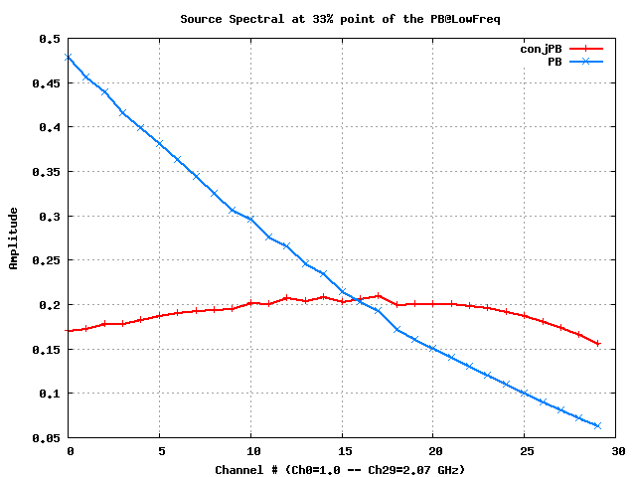

Figure 1: The blue curve shows the spectrum (covering the frequency range of 1.0 to 2.0 GHz) of a unit point source located at the ~33% point of the PB at the low frequency. The image was made using the classical imaging algorithm. The red curve shows the spectrum of the same source, but when imaged using the wide-band A-Projection (WB A-Projection) algorithm. The gain variation as a function of frequency is markedly reduced. The residual frequency variation corresponds to about 5% flux variation across the frequency range.

Beswick and Muxlow of University of Manchester, working with graduate student Nick Wrigley, have characterised the primary beam response of individual telescopes and their combination to create interferometric primary beam response for inhomogeneous telescope arrays. Wrigley's preliminary report is on the RadioNet wiki:

http://www.radionet-eu.org/fp7wiki/lib/exe/fetch.php?media=na:reporting:emerlin_beam_2011_jan_30_4pm.pdf

Richards (UMAN) has developed ready-reckoners for data averaging in time and frequency to study how much one can reduce the size of data sets for continuum imaging without excessive bandwidth or time smearing, and also spectral index, phase rate and dynamic range effects, as a function of the desired field of view. A summary and examples for ALMA and e-MERLIN were presented at the CALIM conference, see:

http://www2.skatelescope.org/indico/materialDisplay.py?contribId=11&sessionId=13&materialId=0&confId=171

Suitable scripts can be provided (for any array meeting the assumptions e.g. dishes) and eventually options might be provided for SPLIT in CASA. Richards has been testing wide field imaging tasks (among others) incorporated in CASA, in liaison with Urvashi Rau.

(6.2.4) Polarization (UCAM)
Dr. Sam George was appointed as a replacement for Joern Geisbuesch and started work on 1 June 2011.

Accurate measurements of instrumental polarization and correction of polarization cross-talk between the components of the Stokes vector is critical to the science of polarimetry. Measuring the Stokes vector resulting form the instrument, one can retrieve the Müller matrix using a non-linear-least-squared fit based on the known fractional form of the matrix of the calibration optics assuming a static instrument Müller matrix. Good polarization calibration must deliver both the instrumental polarization and the position angle calibration. An unpolarized source allows one to determining the instrumental polarization and does not require parallactic angle coverage. A polarized source can only give the position angle calibration and the polarization needs to be known a priori. Sources with unknown polarization need sufficient parallactic angle coverage. Generally the instrumental polarization is solved using a linear approximation where the cross-terms in more than a single product of the instrumental or source polarization are ignored in the measurement equation. This is not a sufficient approach for data where there is high (of order a few percent) instrumental polarization leakage, for this we need a generalised non-linearised solution. This is of course, important for high dynamic range wide field total intensity imaging.

The current implementation in Common Astronomy Software Applications package (CASA) uses the small amplitude approximation. Though this works fairly well on observations with small leakage terms the residual leakage is still seen in the maps produced. University of Cambridge is implementing a non-linear method that removes this restriction. In python (using CASA to access the measurement set) a task, which extracts the useful data from the measurement set efficiently, had been implemented. The observations of a known unpolarized source is then used as a model of the leakage and this signal is removed on a channel by channel basis whilst making the assumption that this is non-time varying. This has been applied to both test data and 610~MHz Giant Metrewave Radio Telescope (GMRT) data. The calibration returned gives a similar scatter to that obtained via CASA's `polcal' task. An improved method of solving the full instrumental Müller matrix is being implemented. Currently, the routine does a fit to the data and returns the Müller matrix per channel, though at the moment when the inverse is applied to the data the results are disappointing. A new set of plotting tools have also been developed inside of CASA using matplotlib - these allow for quick visualisation of the polarization calibration data. For example, these animated plotting of Stokes Q,U as a function of time for all channels, plotting Q/I vs U/I for all times as a function of channel and antenna, showing a given number of antennas.

(6.2.5) Distributed Processing (ASTRON)
The first of a next generation of radio telescopes are coming on-line (LOFAR, ALMA, EVLA). These instruments produce huge amounts of data for which automatic pipeline processing in a distributed environment becomes imperative. The correction for direction-dependent effects in the imaging step is a necessary next step in the processing of the data from the new instruments. This is being investigated within this task. A CASA imager Mwimager script has been written and delivered successfully in the first half of the project.

To correct for direction-dependent effects (like the LOFAR beam) a script has been developed at ASTRON to create and deconvolve the image using facets. The DDE-correction is calculated for the center of the facet and applied to the entire facet. It works well and produced some good images. However, it is quite slow. Therefore, this approach was abandoned and the convolutional approach was further developed.

The work on correcting for direction dependent effects focused on the implementation of AW-projection for time variable, fully polarized beams in CASA See figure 2 and 3. Implementation so far has been for LOFAR primary beams, but the code is set up in such a way that also other primary beams like for ALMA and EVLA can be added. The LOFAR Primary Beam can be seen as the union of EVLA, ALMA, and MeerKAT primary beams. A first functional implementation was achieved. Investigation of the underlying measurement equation showed that ionospheric direction dependent effects can be corrected in a similar fashion as primary beams. Implementation of ionospheric correction, however, falls outside the scope of this ALBiUS task.

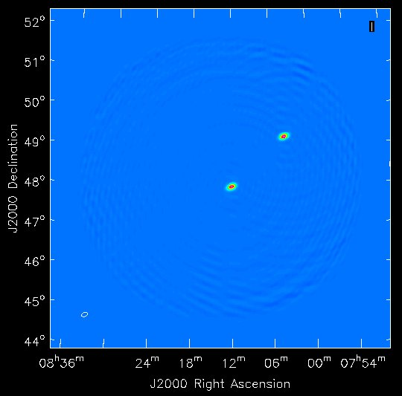
Figure 2: Two simulated point sources are recovered to within 1% in all four polarizations.

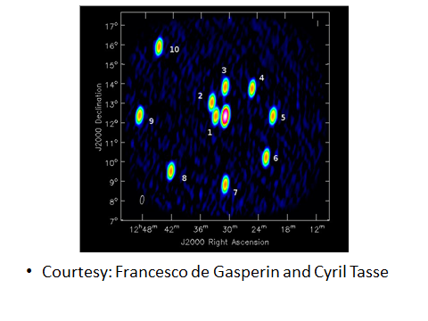
Figure 3: LOFAR data were simulated with BBS inside an LBA observation of VirgoA.

Figure 2 shows two simulated point sources that have been successfully recovered to within 1% in all four polarizations. Figure 3 shows simulated data of a single point source (10 Jy) in the center of the field, plus 10 more 1 Jy point sources placed on a spiral around the central one, up to a distance of 5 deg. Fluxes in the QUV stokes are set to 0. An image of the simulated data was made using the AW-Projection method. As expected, the farther we go from the phase center, the lower the uncorrected values are. This is not true for source 10, a possible explanation is the asymmetry of the primary beam shape. Anyway, AWImager has been reliable ( ~ 1-3 % of error probably due to deconvolution effects) in reconstructing the simulated flux even at 5 deg from the phase center. A value compatible with 0 has been found in stokes QUV. The initial implementation of AWProjection proved to be slower than real time for a typical LOFAR dataset. A number of optimizations were implemented and are currently in the final testing stages.

In parallel to the work on the correction for direction dependent effects in the Imager four papers were published on direction dependent calibration. The final report on the implementation of AWProjection awaits the results from the final tests. It is expected that the final report will be delivered by April 1st 2012.

NRAO has contributed to multi-process imaging for continuum and spectral cube, which was first achieved early in this reporting period. The work during 2011 was focussed on dealing with data-parallel optimization for problems that require minimal inter-process communication. The new infrastructure has lead to an easy path for implementing parallelization of different modules of a data reduction pipeline (e.g., flagging, calibration application or continuum subtraction) by distributing the work on different dataset subsets across different processors.
CASA release 3.3 was made publicly available during this reporting period and is the first release to include useful parallelized imaging algorithms. With this release, Multi-Scale clean and Multi-Scale-Multi-Frequency-Synthesis now use OpenMP-based multithreading. At the toolkit level, parallel imaging for both continuum and spectral-line cube cases is available. Additionally, a framework for making parallel tasks (such split, applycal, ...) is in place.

(6.2.6) Astrometric Positions (BORD)
The purpose of the ALBiUS task on astrometric calibration is to devise, implement and test algorithms that combine wide-angle astrometry with narrow-angle (phase-referenced) astrometry. After reviewing the capabilities of existing software packages (discussed in the mid-term report), the choice was made to use the MODEST package (which is developed and maintained by the Jet Propulsion Laboratory) to this end. The work focused on generating appropriate datasets and developing the necessary tools to simulate the desired combination, taking advantage of the MODEST capabilities.

The work was split into four successive steps which are described below:
- simulate group delay observations, the basic quantities used for wide-angle (or global) VLBI astrometry;
- simulate phase delay observations, the quantities used in narrow-angle (or phase-referenced) VLBI astrometry;
- combine the simulated group delay and phase delay VLBI data in a unified analysis to derive astrometric and geodetic parameters;
- implement and test VLBI observing strategies that combine the two datasets and assess the quality of the results and the relevance of such a combination.

Bordeaux observatory has successfully accomplished the first three steps. A specific point regarding the simulations in steps 1 and 2 is the inclusion of elevation-dependent tropospheric noise so that realistic uncertainties are obtained for the simulated datasets. In step 3, dual-frequency S band (2.3 GHz) and X band (8.4 GHz) group delay observations have been combined with X band phase-delay observations as these are standard astrometric data sets for which the method would most likely be used in the future. Validation of the combination in step 3 serves as a basis for step 4, now underway. The deliverable is a final report on new algorithms and observing strategies for astrometry, which will be provided upon completion of the project on 30 June 2012. The work has been delayed compared to the initial plan for two reasons: (i) a late start due to delay in hiring personnel (the postdoc working on the task started on month 15.5 instead of month 8 stated in the description of work), and (ii) difficulties in generating simulated phase delays which took more time than originally thought due to problems with software and data formats when dealing with these quantities.

3. Large Datasets
Quality Control
(6.3.1) RFI Mitigation (MPG)
Final software, documentation, and report on RFI mitigation in focal plane arrays was delivered in DiFX and C++ libraries, and is available in the RadioNet wiki:

http://www.radionet-eu.org/fp7wiki/lib/exe/fetch.php?media=jra:albius:beamformer-0.1.0-ug.pdf
http://www.radionet-eu.org/fp7wiki/lib/exe/fetch.php?media=jra:albius:beamformer-0.1.0-refman.pdf
http://www.radionet-eu.org/fp7wiki/lib/exe/fetch.php?media=jra:albius:beamformer-0.1.0.tar.gz
https://svn.atnf.csiro.au/difx/libraries/beamformer/
Good performance was demonstrated in mitigating RFI in simulated data especially with reference antennas. An algorithm improvement over those previously published yielded much improved mitigation at low interference-to-noise ratio. Beamformer design for Effelsberg APERTIF tile has been modified to provide the full covariance matrix needed to apply these algorithms.
Figures illustrating the mitigation performance are available in the User Guide (beamformer-0.1.0-ug.pdf), available in the RadioNet wiki (see above).

The multi-rate filter for RFI mitigation was implemented in DiFX and used for correlation of an EVN observation of OH in Cyg A, and NGC 1068 (E10C014) for RFI mitigation test. Spectra made with and without RFI mitigation have been compared to validate the mitigation effectiveness. This revealed that RFI from GPS is present in some baseline spectra as expected by the design of the test observation. Surprisingly however, RFI mitigation was not effective and sometimes even made the RFI stronger.
MPIfR has generated synthetic recordings for two of the EVN stations (Effelsberg and Westerbork), consisting of, selectably, uncorrelated noise, correlated noise, GPS carrier, and GPS carrier modulated with C/A code. Then they correlated the synthetic data (noise plus modulated GPS carrier) in DiFX and in Matlab and obtained the same results, which verified the correctness of the DiFX implementation of the multi-rate filter for RFI mitigation.
Then MPIfR has focussed on the filter characteristics in detail. The filter infrastructure implemented in DiFX passed the validation test shown in Figure 4, in which the GPS tone near 22 Hz fringe rate was mitigated by 70 dB. This is an excellent result.
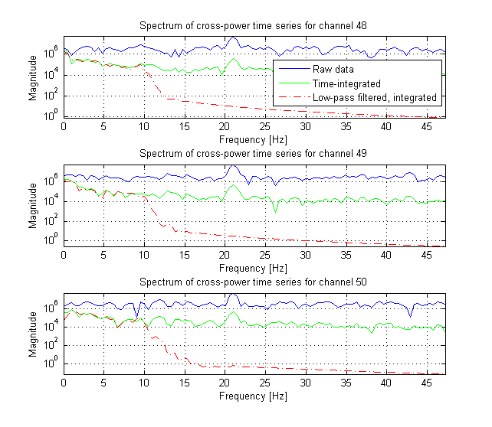
Figure 4: Fringe frequency spectra zoomed to 0-45 Hz for channels 48 to 50. Spectra are Hanning windowed Fourier transforms of the cross-correlation time series of a channel. The 1 MHz BPSK modulation by the GPS CA chip sequence was enabled. Modulation spreads the GPS carrier in channel 49 across neighboring channels. Spectra of raw cross-correlation data (solid blue) show GPS at a 22 Hz fringe frequency. Mean filtering reduces GPS levels in the time series by ~20 dB (solid green). A 10 Hz low-pass filter alone suppresses GPS by ~50 dB but if followed by a mean filter, GPS is suppressed ~70 dB over the original (dashed red).
However, the final baseline visibility spectrum unexpectedly still contains the GPS tone, mitigated by only 3 dB, shown in Figure 5 This is inconsistent with the result in Figure 4, and the reason is not yet entirely understood.
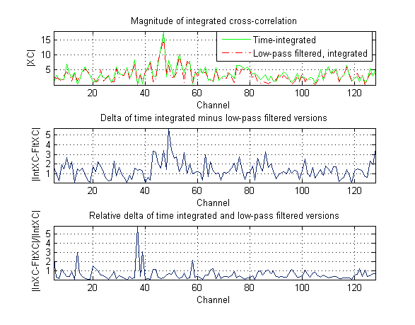
Figure 5: Cross-correlations in all 128 channels after T=2.094 seconds, the final baseline visibility. Although Figure 1 demonstrates low-pass mean filtering with 50 dB improved GPS suppression compared to mean filtering alone, the final visibility still contains significant amounts of GPS (dashed red, top). There is almost no reduction in level compared to mean filtering (solid green, top). The absolute difference |int(xc) - flt(xc)| is sometimes larger because low-pass mean and mean results have different phase (middle). The final low-pass mean filtered visibility fails to demonstrate the expected 50 dB decrease in GPS level. The reason is not yet entirely understood.

It has been also tested whether the modulation of the RFI was causing poor mitigation by switching off the modulation and repeating the first two tests with noise plus pure tone. The result (good mitigation in the fringe-rate spectrum but poor mitigation in the final baseline spectrum) was repeatable, seen in Figure 6 and Figure 7.
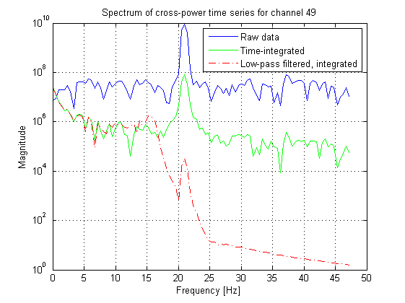
Figure 6: Fringe frequency spectra zoomed to 0-45 Hz for channel 49 data with a clean GPS carrier and no modulation. The spectrum of the raw data time series (solid blue) is overlaid with spectra from mean filtered data (solid green), and using 16 Hz low-pass mean filtering increases the GPS suppression from ~30 dB to ~60 dB (dashed red).
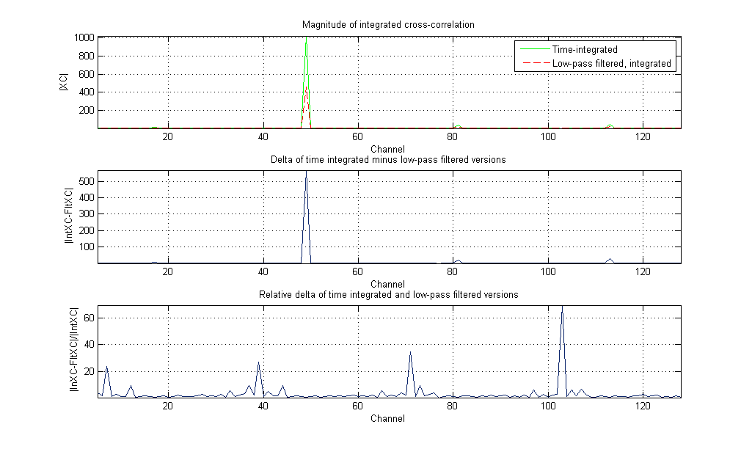
Figure 7: Cross-correlations in all 128 channels after T=2.094 seconds, the final baseline visibility. No GPS carrier modulation. As in Figure 1 with CA chip modulation, even now the final visibility has more GPS signal than anticipated. For the low-pass mean filtered data the final visibility (dashed red, top) happens to be reduced by factor 2 (3 dB << 40 dB) compared to the mean filtered (solid green, top). This is depends however on the choice of time T. Further, the integrated and filtered complex visibilities have different phase, resulting in a possibly larger absolute difference |int(xc) ? flt(xc)| (middle). The normalized absolute difference (bottom) shows certain channels such as channel 104 with noise seemingly enhanced by the filter.

Finally it has been tested whether the poor mitigation might be coming from an unexpectedly long filter settling time, in which case the settling could be accelerated by initializing the filter at the start of the accumulation period. The test result showed that the filter was settling rapidly and that initialization was not necessary, seen in Figure 8. This same test explained how the RFI could be stronger after mitigation; when the sinc ring-down function of the standard integrator chances to pass through a null then the RFI is mitigated below the level of the IIR filter.

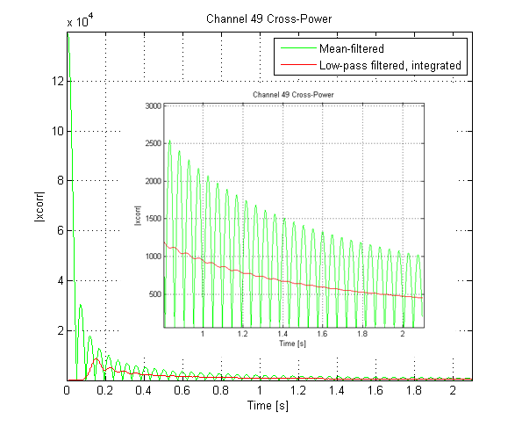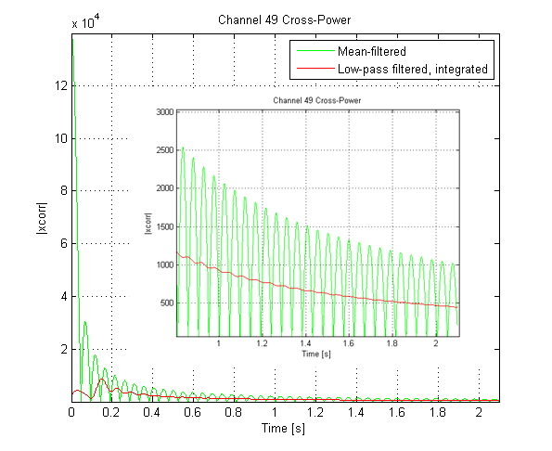
Figure 8: Absolute value of filtered time series when using uninitialized filters (left panel) and initialized filters (right panel). Channel 49 contains a clean GPS carrier and no modulation. The DiFX mean filtered output exhibits a large sinc(x) ripple pattern due to the poorly attenuated GPS tone (green curve). You may compare this ripple to the 22 Hz fringe frequency in Figure 6. The filter output from a two stage filter that consists of a 16 Hz low-pass followed by a mean filter reduces the ripple by ~60 dB (red). For an uninitialized low-pass the output starts from zero (left panel, red). Before filtering actual data the low-pass section may also be initialized first by Gaussian noise equal to the expected later level. In this case the output starts from the estimated noise mean (right panel, red). In both cases the filter output after 100 ms is essentially identical and converges equally fast.

In conclusion, RFI mitigation in focal plane arrays works well and is delivered (including software, documentation and user guide). Furthermore, RFI mitigation in DiFX is implemented. The performance tests are mixed, showing fringe-rate spectra with an excellent 70 dB of mitigation, but RFI remains in the final baseline spectra.

(6.3.2) Data Inspection (UOXF)
University of Oxford has worked on metadata inspection and on visibility quality control. It has been acquired knowledge about UVFITS to MS flagging, though it has not been implemented into software/concepts. Novel calibration algorithm for quality control has been tested. This effort makes use of GMRT data in combination with the GMRT pipeline. A first software module of the calibration code has been developed (Dulwich) and is currently implemented to work within ParselTongue and the GMRT pipeline (Kloeckner). First test has been done, but there are still some minor issues related to data modelling in AIPS. Closure phase plots will be developed in order to evalutate the correctness of the calibration modules.

(6.3.3) Source Parameterization (ASTRON)
The objective of this task is to make new source parameterization approaches available for data processing.

A sky model tool called Tigger (http://www.astron.nl/meqwiki/Tigger) is developed for using various source representations in the data processing. The current implementation includes support for point sources, Gaussian extended sources, and FITS images, and can be easily extended to support shapelets. The Tigger tool is written entirely in Python, and uses a modern PyQt-based GUI (see Figure 9). The use of Python means that it can be very rapidly developed and extended. A conversion tool is provided for converting native Tigger models to or from generic ASCII tables, BBS model files and NEWSTAR MDL files. Tigger is freely available under the terms of the GPL. A binary package has been included in the MeqTrees binary distribution maintained by Oxford e-Research Centre (OeRC), see ASTRON webpage for details:
http://www.astron.nl/meqwiki/Downloading for details.

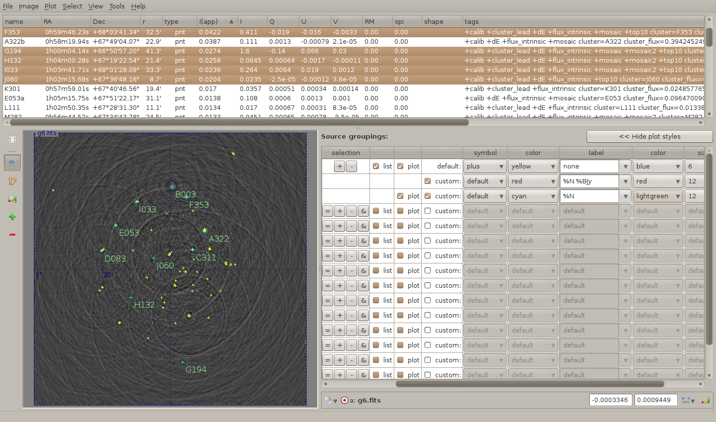
Figure 9: Screenshot of the Tigger tool.Test fields (ASTRON)
Tigger has been successfully employed in a number of calibration projects both within and outside ASTRON:

- The QMC/QMC2 reductions (O. Smirnov, ASTRON, see e.g. CALIM 2011 talk http://www2.skatelescope.org/indico/getFile.py/access?contribId=20&sessionId=9&resId=0&materialId=0&confId=171) used Tigger for all sky model management.
- Ian Heywood (Oxford Astrophysics) has used Tigger for his 8.4 GHz EVLA project, reported e.g. here: http://www.astron.nl/dailyimage/index.html?main.php?date=20111014
- O. Smirnov has recently demonstrated the use of hybrid sky models with Tigger. This is ongoing work involving WSRT 92cm observations of the Abell 773 cluster (PI: R. Pizzo).

Work on the final report has already started. The report is expected to be delivered by March 1st.

