List of working documents

Oleg Smirnov published another paper on Calibration and direction dependent effects (see attached document).

Main Activities during

The work on correcting for direction dependent effects focused on the implementation of A-projection for time variable, fully polarized beams in CASA. A first implementation was delivered. Initial testing on simulated data showed good results. Now further testing is needed and the performance of the code should be investigated on real data. Testing so far has been on LOFAR primary beams, but the code is set up in such a way that also other primary beams like for ALMA and EVLA can be added. The LOFAR Primary Beam can be seen as the union of EVLA, ALMA, and MeerKAT primary beams.
Investigation of the underlying measurement equation showed that ionospheric direction dependent effects can be corrected in a similar fashion as primary beams. Implementation of ionospheric correction, however, falls outside the scope of this ALBiUS task.
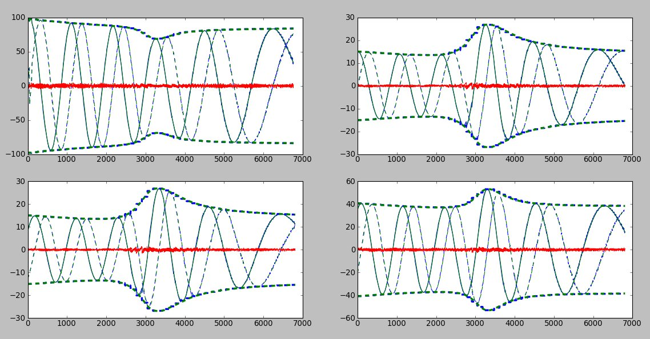
Figure 1: Comparison of BBS DFT Predict against AWProjection de-gridding for the four correlations XX, XY, YX, and YY.

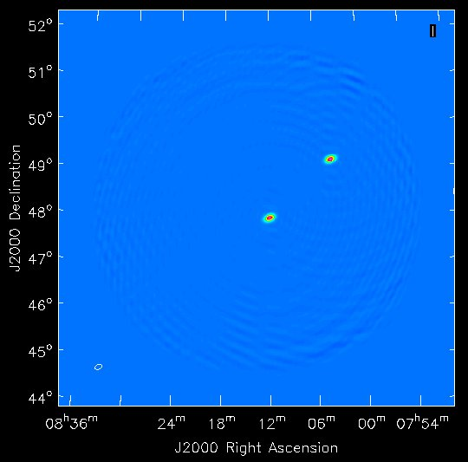
Figure 2: Two simulated point sources are recovered to within 1% in all four polarizations.

Meetings attended by people involved

In May Ger van Diepen travelled to NRAO in Socorro to work with Sanjay Bhatnagar on the implementation of AWProjection for LOFAR Primary Beams in CASA.

Problems / Issues

None

Red flags - major problems

None

Forward Look

The AWProjection implementation will be further tested. Final reports for the ALBiUS tasks will be written.

